**XY Pharmacies Chain Database System**

**By**

Yehya Moh’d Khair Khaleel Al-Mubaideen 20102171058 sec: 2

Ahmad Thabet Shraide 20102175023 sec: 2

Rima Ziad Abu-Dalo 20100173099 sec: 4

Course Title: Database Systems (CIS 228)

Instructor: Dr. Hassan Najadat

DBMS: ORACLE 11g XE

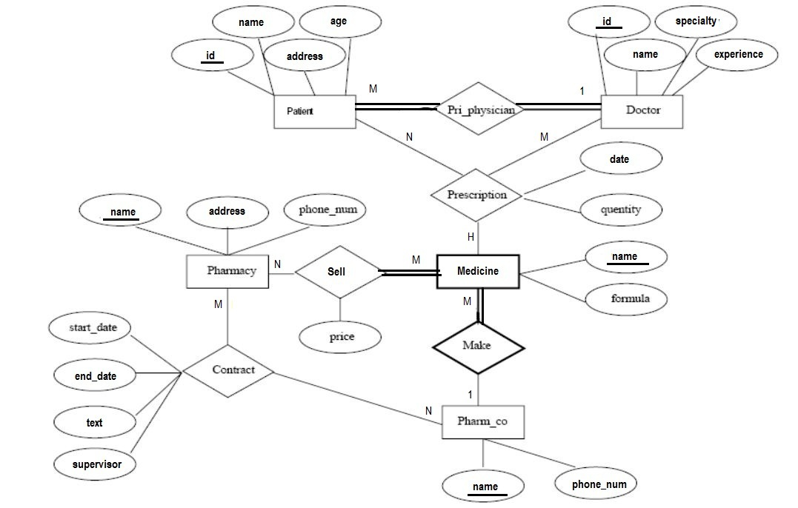

Figure 1

The ER conceptual schema diagram for the XY Pharmacies Chain database

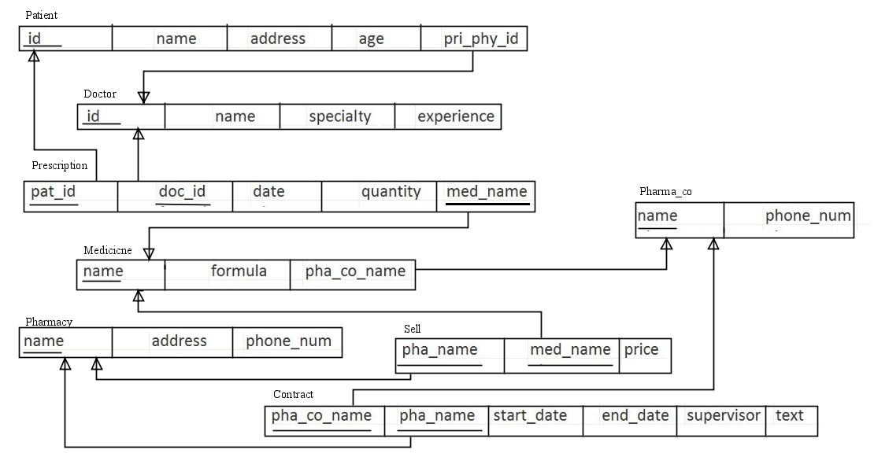

Figure 2

The relation model schema for the XY Pharmacies Chain database

**SQL scripts:**

create table Patient

(id char(8),

name varchar2(25),

address varchar2(25),

age number,

pri_phy_id char(8) constraint patient_pri_phy_id_nn not null,

constraint patient_id_pk primary key (id)

);

create table Doctor

(id char(8),

name varchar2(25),

specialty varchar2(25),

experience number,

constraint doctor_id_pk primary key (id)

);

create table Prescription

(pat_id char(8),

doc_id char(8),

last_date date,

quantity number default 1,

med_name varchar2(25),

constraint prescription_composite_pk primary key (pat_id, doc_id, med_name)

);

create table Pharma_co

(name varchar2(25),

phone_num number(10) constraint pharma_co_phone_num_uk unique,

constraint pharma_co_name_pk primary key (name)

);

create table Medicine

(name varchar2(25),

formula varchar2(25),

pha_co_name varchar2(25),

constraint medicine_name_pk primary key (name)

);

create table Pharmacy

(name varchar2(25),

address varchar2(25),

phone_num number(10) constraint pharmacy_phone_num_uk unique,

constraint pharmacy_name_pk primary key (name)

);

create table Sell

(pha_name varchar2(25),

med_name varchar2(25),

price number(5,2) constraint sell_price_nn not null,

constraint sell_composite_pk primary key (pha_name, med_name)

);

create table Contract

(pha_co_name varchar2(25),

pha_name varchar2(25),

start_date date,

end_date date,

supervisor varchar2(25) constraint contract_supervisor_nn not null,

text varchar2(25),

constraint contract_composite_pk primary key (pha_co_name, pha_name)

);

alter table Patient add constraint patient_pri_phy_id_fk foreign key(pri_phy_id) references Doctor(id);

alter table Prescription add constraint prescription_pat_id_fk foreign key(pat_id) references Patient(id)

on delete cascade;

alter table Prescription add constraint prescription_doc_id_fk foreign key(doc_id) references Doctor(id);

alter table Prescription add constraint prescription_med_name_fk foreign key(med_name) references Medicine(name);

alter table Medicine add constraint medicine_pha_co_name_fk foreign key(pha_co_name) references Pharma_co(name)

on delete cascade;

alter table Sell add constraint sell_pha_name_fk foreign key(pha_name) references Pharmacy(name)

on delete cascade;

alter table Sell add constraint sell_med_name_fk foreign key(med_name) references Medicine(name)

on delete cascade;

alter table Contract add constraint contract_pha_co_name_fk foreign key(pha_co_name) references Pharma_co(name);

alter table Contract add constraint contract_pha_name_fk foreign key(pha_name) references Pharmacy(name);

**Populated Database:**

select * from patient

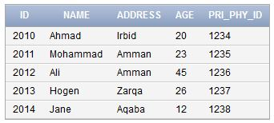

select * from doctor

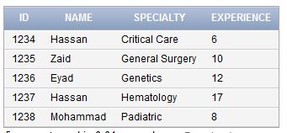

select * from medicine

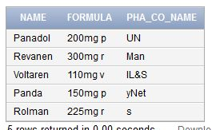

select * from prescription

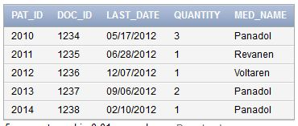

select * from pharmacy

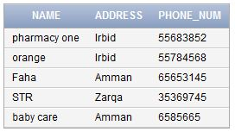

select * from pharma_co

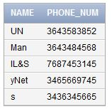

select * from sell

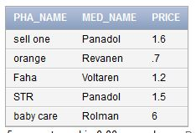

select * from contract

